User Manual
Web-Based Vehicle Auction Platform
Prepared for TaproJapan Co. Ltd.

1. Introduction
This manual explains how to use the Web-Based Vehicle Auction Platform. It is written for three types of readers: Guests browsing the public catalogue, registered Buyers who place bids, and Administrators who manage vehicles, auctions, and user accounts. Each section below is organised around a specific task, and screenshots are provided to show exactly what you will see on screen.

1.1 Who This Manual Is For
Reader | Relevant Sections
Guest (not logged in) | Sections 3, 4.1 – 4.5
Registered Buyer | Sections 3, 4.1 – 4.9, 6
Administrator | Sections 3, 5.1 – 5.5, 6

1.2 Accessing the System
The platform is accessed through any modern web browser (Google Chrome, Mozilla Firefox, Microsoft Edge, or Safari). No installation is required. Enter the system's web address in the browser's address bar to open the vehicle catalogue.
Recommended screen resolution: 1280 × 720 or higher for the best layout on the admin dashboard. The site is also usable on mobile phones and tablets.

2. User Roles Overview
The system defines three levels of access. A visitor's capabilities expand as they register and are verified by an administrator.
Role | How Obtained | Capabilities
Guest | No action needed — default for any visitor | Browse the vehicle catalogue and auctions; view bid history and winner pages
Buyer (unverified) | Self-registration at the Register page | All Guest capabilities; cannot place bids until verified by an administrator
Buyer (verified) | Approved by an administrator after registration | All Guest capabilities plus placing bids on active auctions
Administrator | Created only by the system owner (not self-service) | Full control: manage vehicles, auctions, and users; verify buyers; close auctions and select winners

3. Getting Started

3.1 Creating an Account
New buyers must register before they can bid. Follow these steps:
- Open the platform in your browser and click Register in the top navigation bar.
- Fill in your full name, email address, and a password.
- Click Create Account.
- You will be redirected to the Login page with a confirmation message that your account was created.
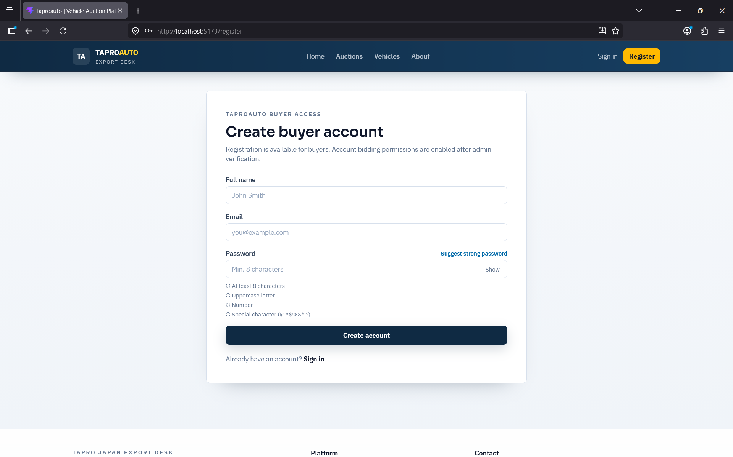
Note: A newly registered account cannot place bids immediately. An administrator must verify your account first - see Section 4.6.

3.2 Logging In
- Click Login in the top navigation bar.
- Enter your registered email address and password.
- Click Login.
On successful login you are redirected automatically: administrators are taken to the Admin Dashboard, and buyers are taken to the Auctions page.

3.3 Navigating the Homepage
The top navigation bar is visible on every page and provides links to Vehicles, Auctions, and (once logged in) your Profile. Administrators additionally see an Admin link with a red badge showing the number of buyer accounts awaiting verification.
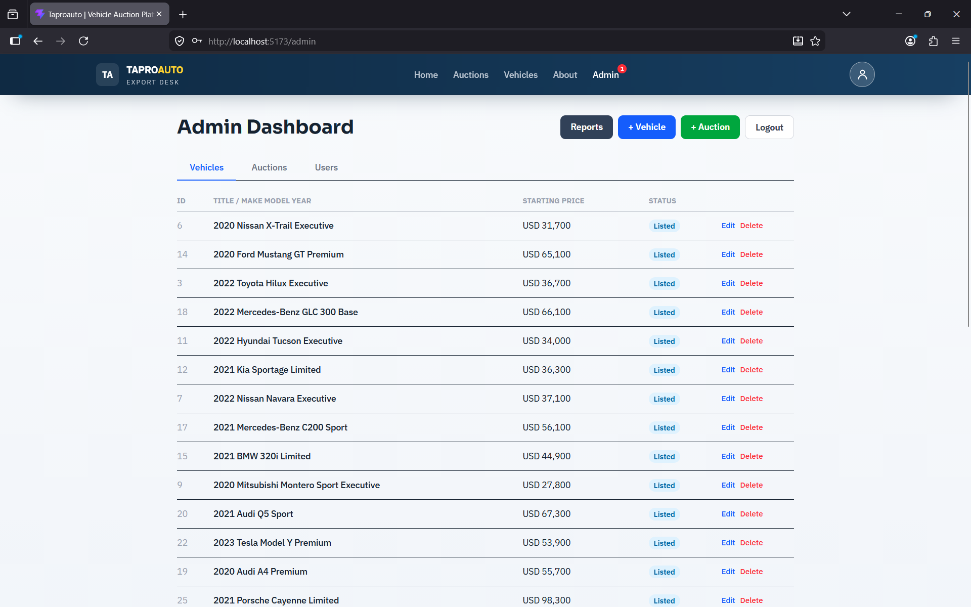

4. Buyer Features

4.1 Browsing the Vehicle Catalogue
The Vehicles page lists all listed vehicles as cards showing a thumbnail image, make, model, year, and starting price. Use the pagination controls at the bottom of the page to move between pages of results.
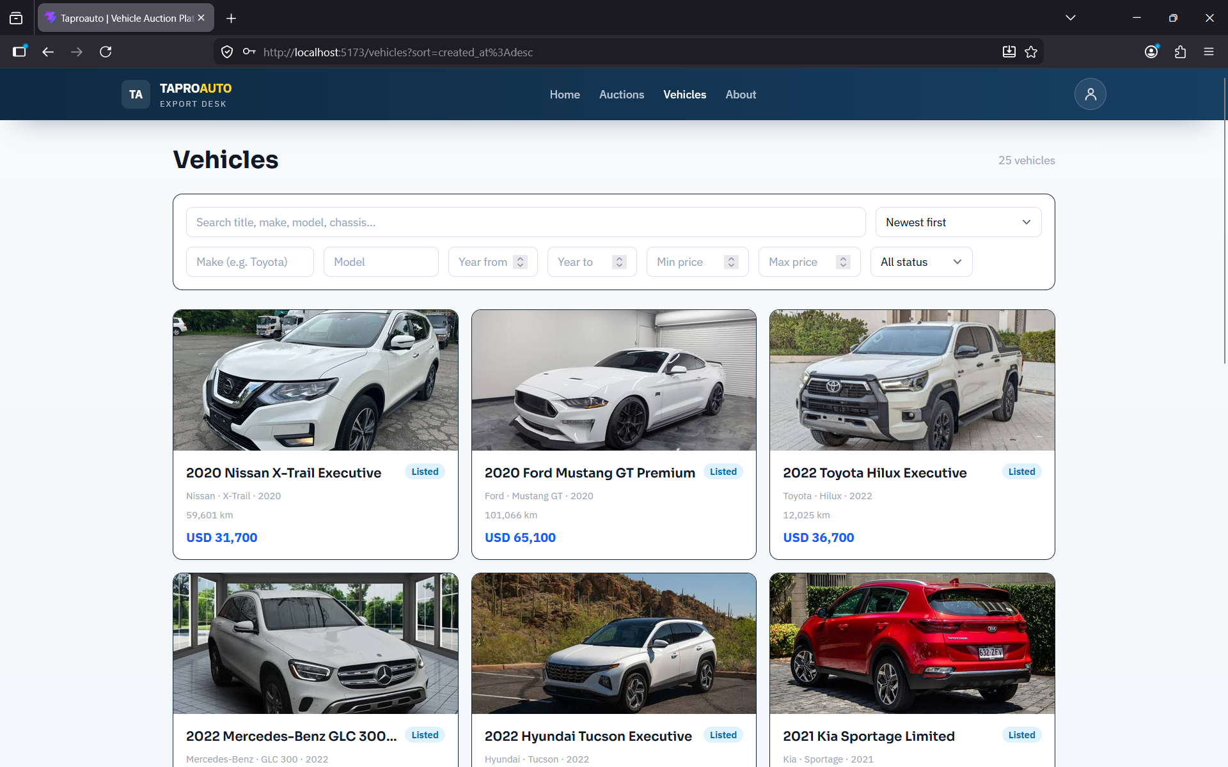

4.2 Filtering and Searching Vehicles
Use the filter panel at the top of the Vehicles page to narrow results by make, model, year range, and price range. Filters are reflected in the page's web address, so you can bookmark or share a filtered search with someone else.
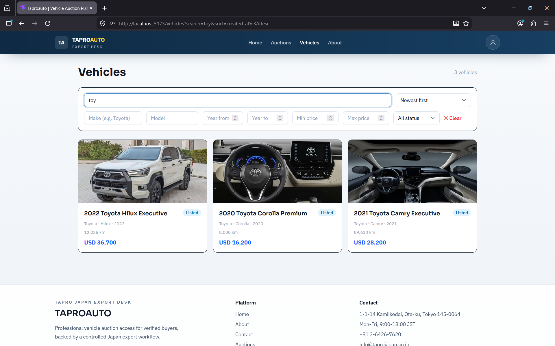

4.3 Viewing Vehicle Details
Click any vehicle card to open its detail page, which shows the full specification (chassis number, mileage, grade), an image gallery, and a link to its associated auction if one exists.
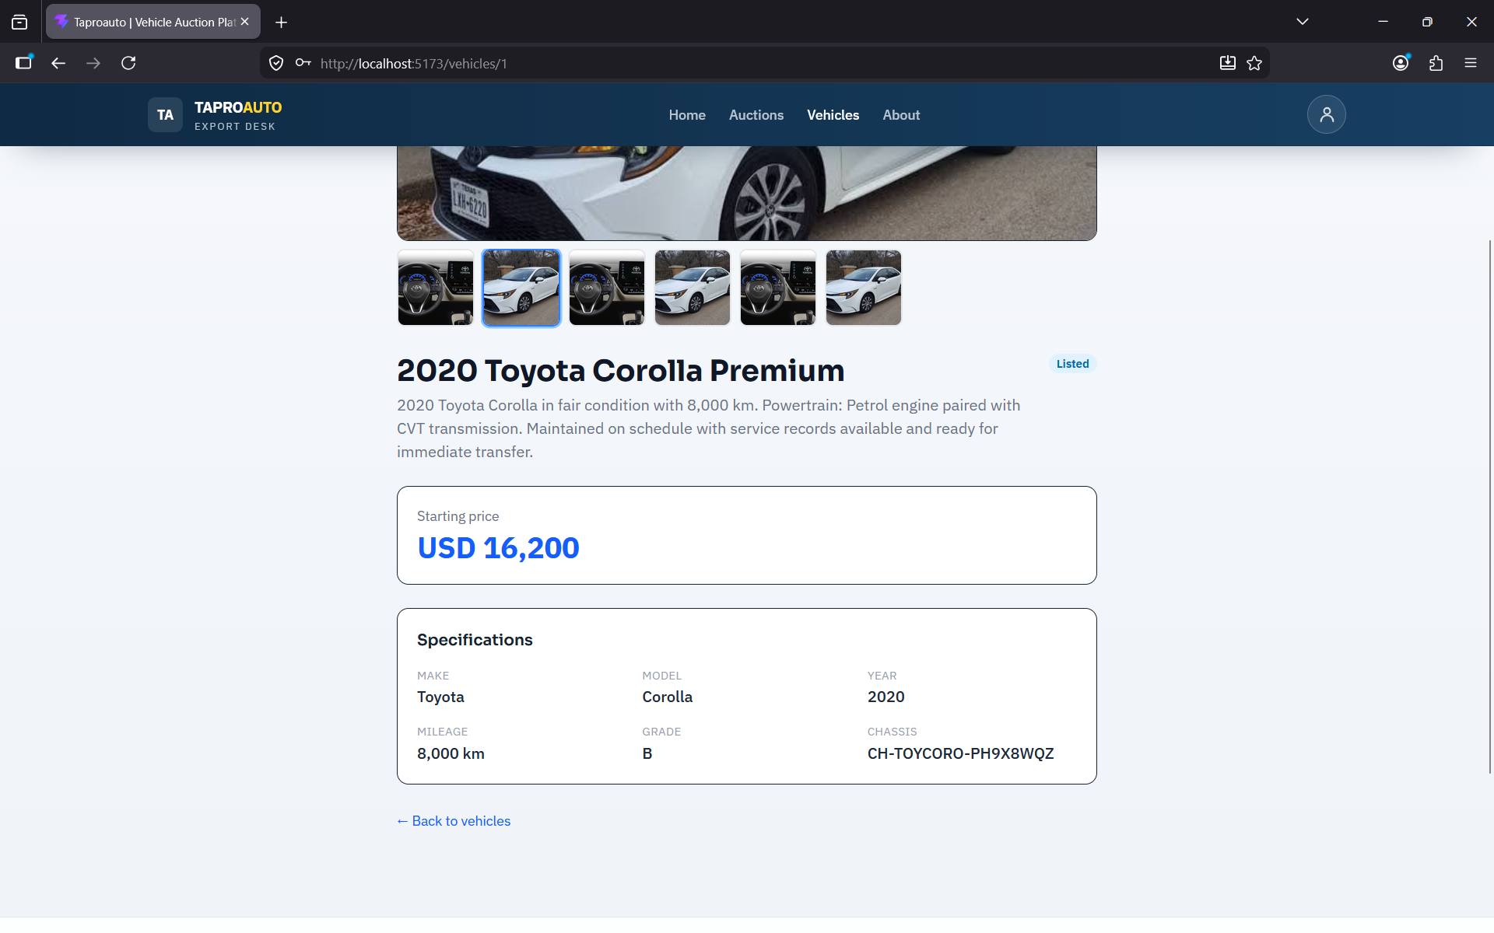

4.4 Browsing Auctions
The Auctions page lists all auctions with a status badge (Draft, Active, or Ended) and, for active auctions, a live countdown timer showing the time remaining.
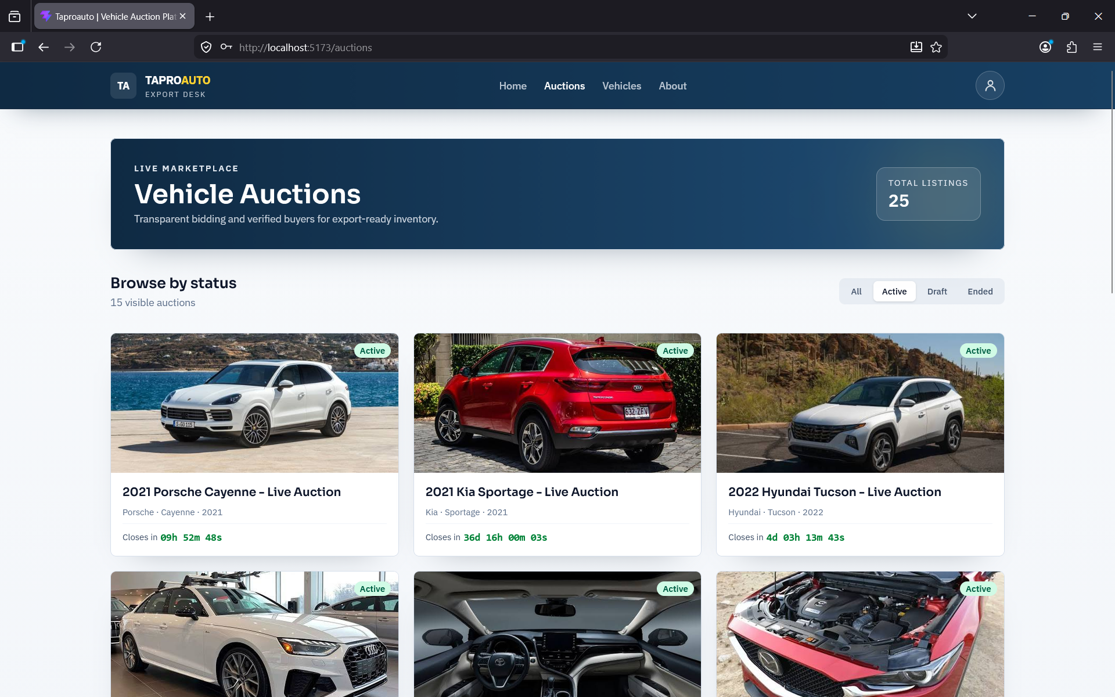

4.5 Viewing Auction Details
Opening an auction shows the vehicle's image gallery (click the main image for a full-screen view; use the arrow keys to move between images and Escape to close), the current highest bid, the full bid history, and a reserve price indicator.
The reserve indicator shows one of three states: no reserve set, reserve not yet met, or reserve met. Buyers see only this indicator; the actual reserve amount is visible to administrators only.
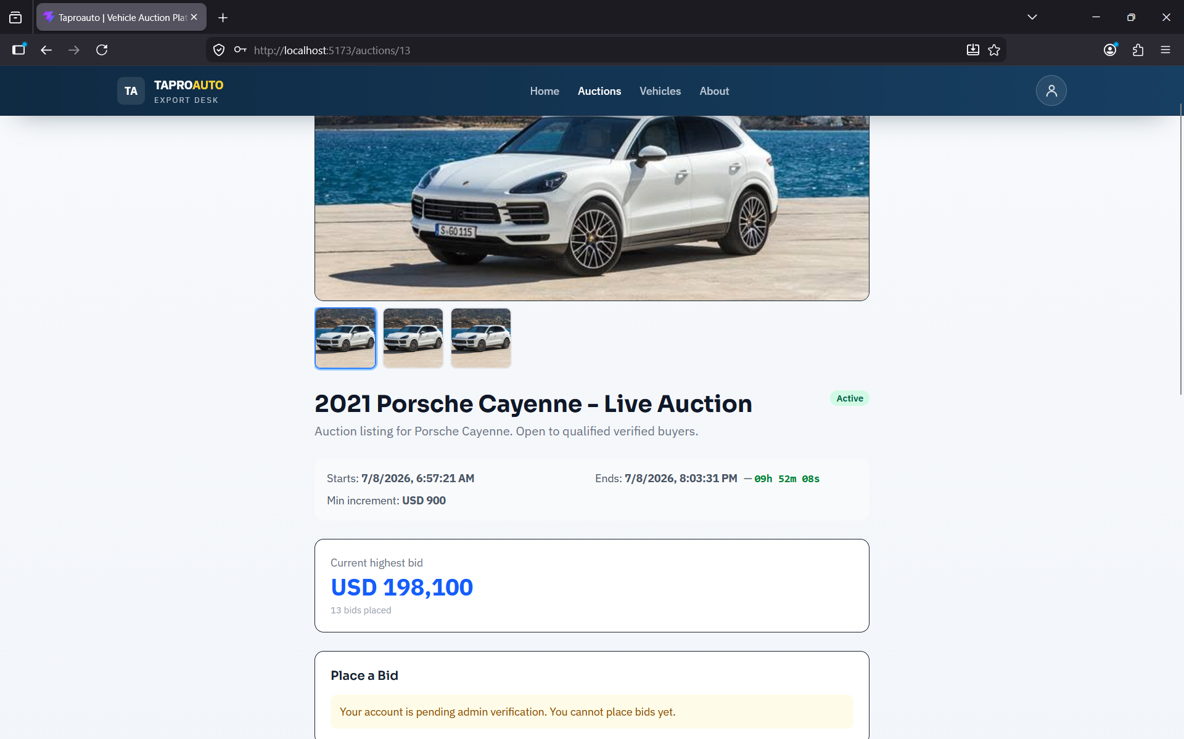
Note: The auction page automatically refreshes bid data every 15 seconds while the auction is active, so you do not need to reload the page to see new bids.

4.6 Account Verification
Before you can place a bid, an administrator must verify your account (see Section 5.4). You can check your verification status at any time on your Profile page. If you log in before your account is verified, log out and log back in after verification so your session reflects the update.

4.7 Placing a Bid
Once verified, a bid form appears at the bottom of any active auction's detail page.
- Open the detail page of an active auction.
- Enter a bid amount that is at least the current highest bid plus the minimum increment shown on the page.
- Click Place Bid.
- Your bid appears immediately at the top of the bid history table.
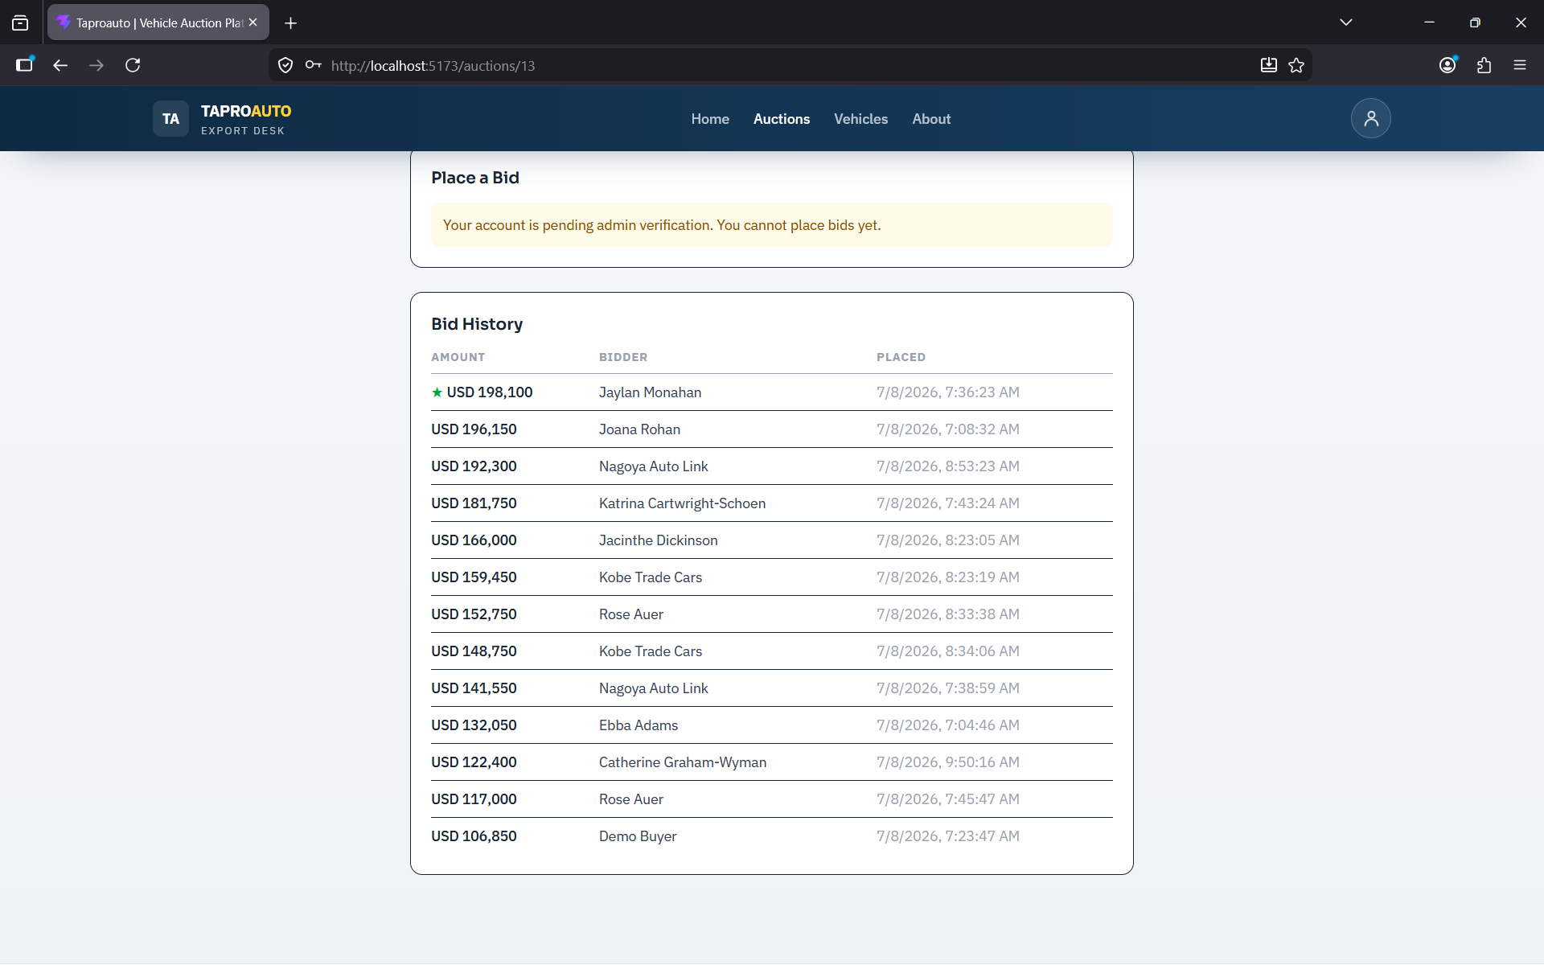
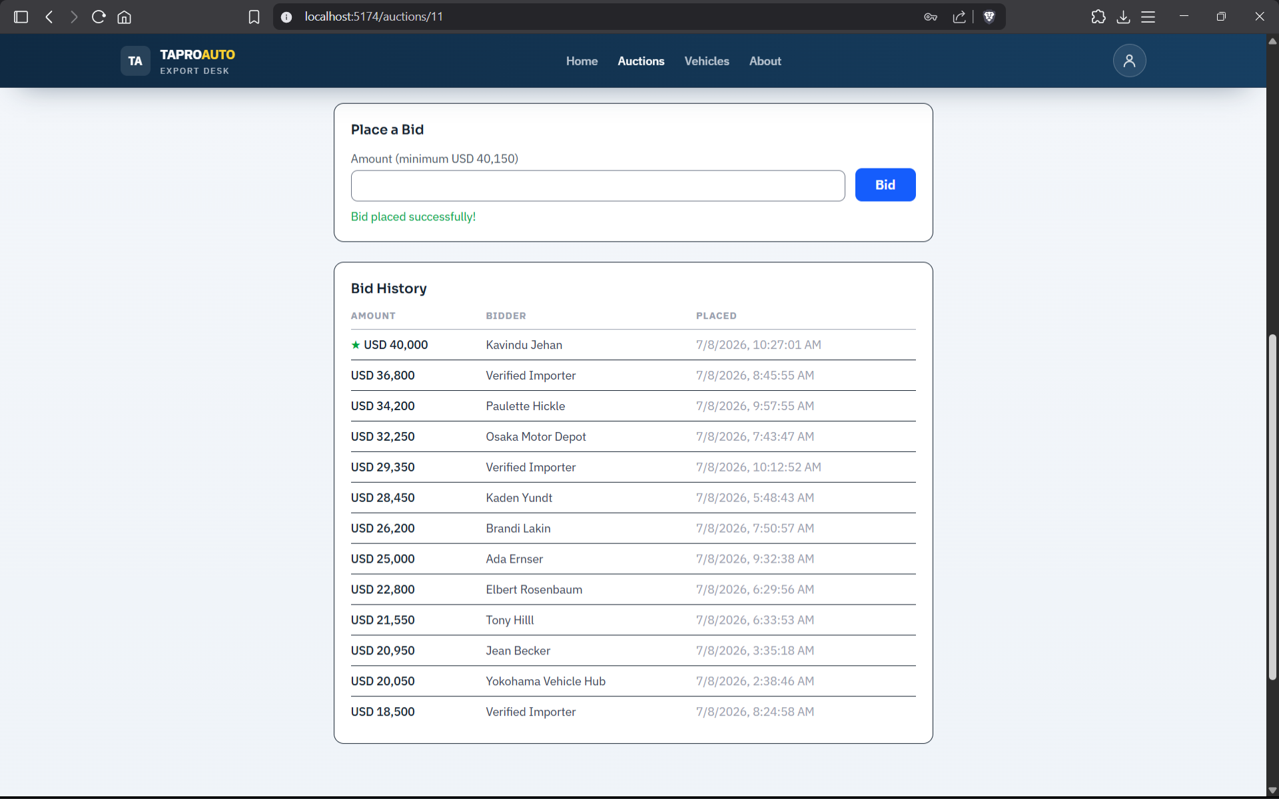
Note: If your bid is below the required minimum, the system rejects it and displays an error message stating the minimum acceptable amount.

4.8 Winning an Auction
When an auction closes, the highest bid is either automatically selected as the winner or confirmed by an administrator. If you win, a green "You Won!" banner appears at the top of the site the next time you visit while logged in. Click the banner's close icon to dismiss it — it will not reappear.
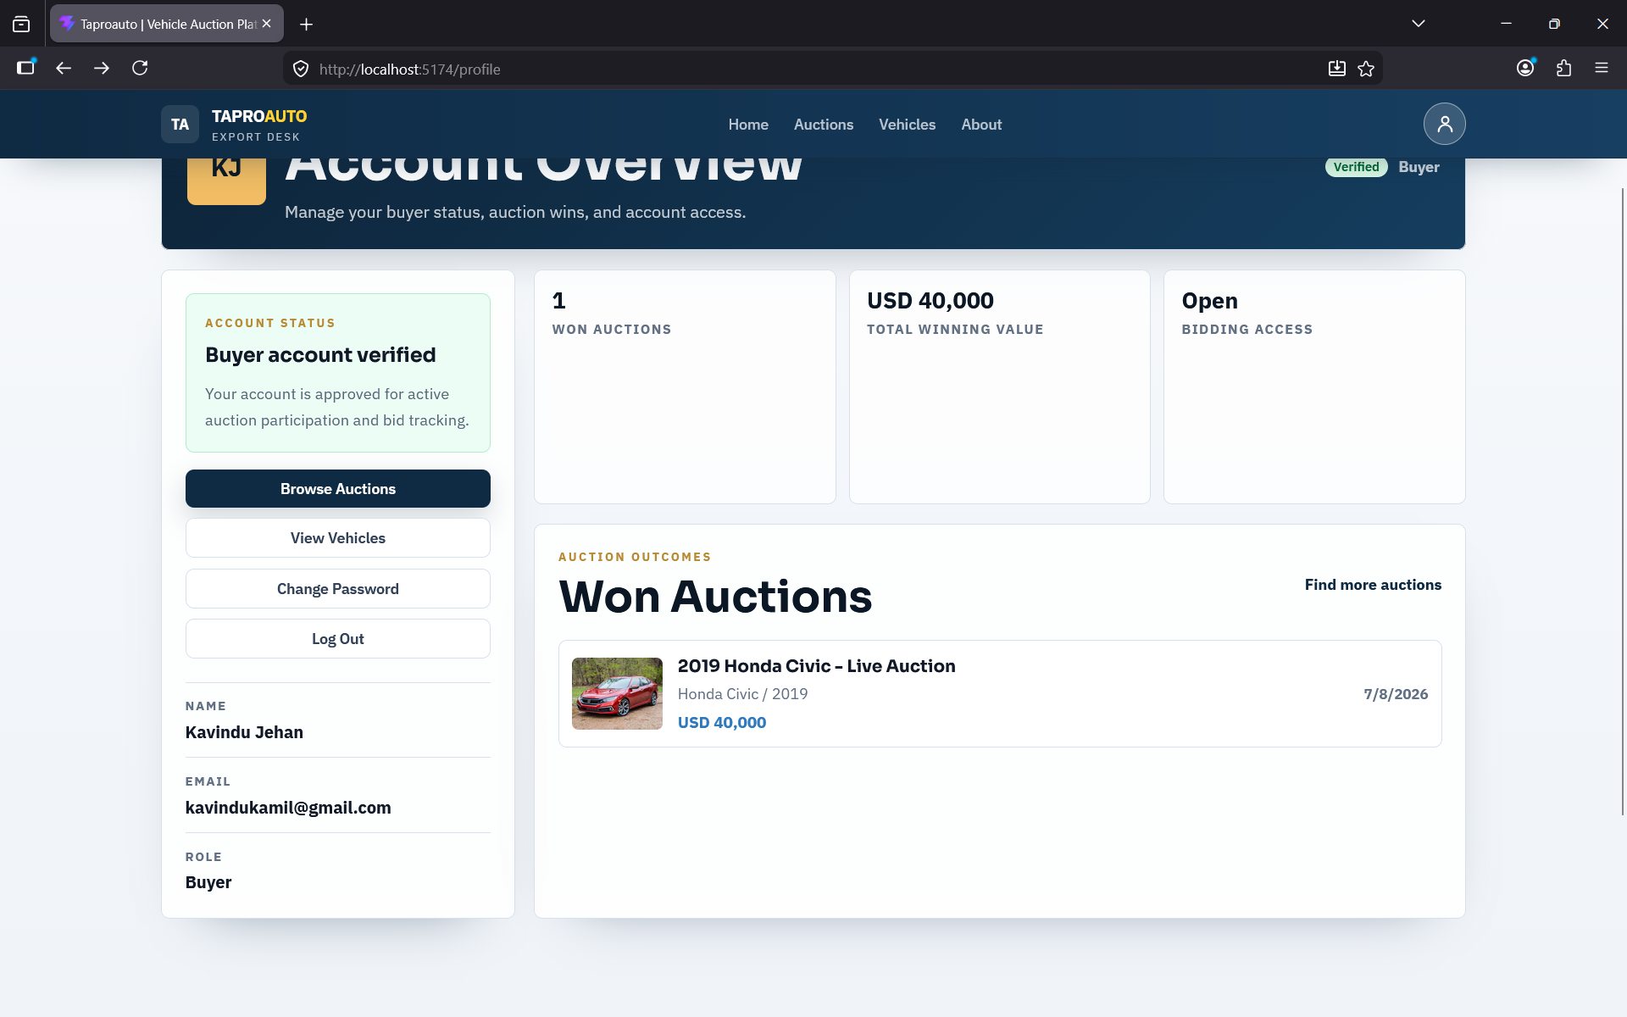
Anyone can view the public Winner page for a closed auction, which shows the winning buyer's name and the winning bid amount.
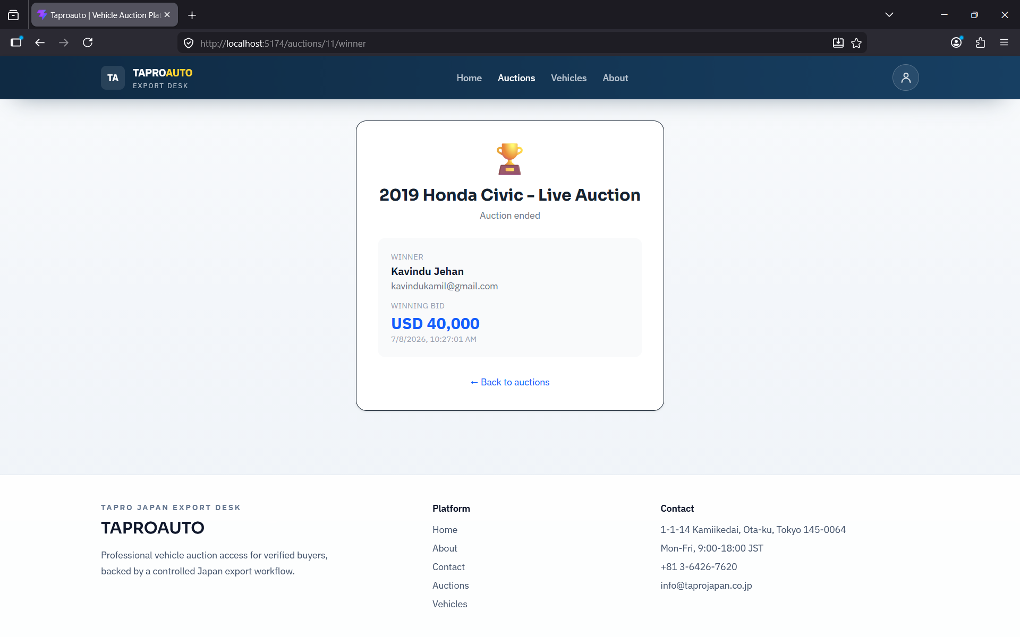

4.9 My Profile
The Profile page shows your account details, current verification status, and a list of auctions you have won, including the winning bid amount for each.
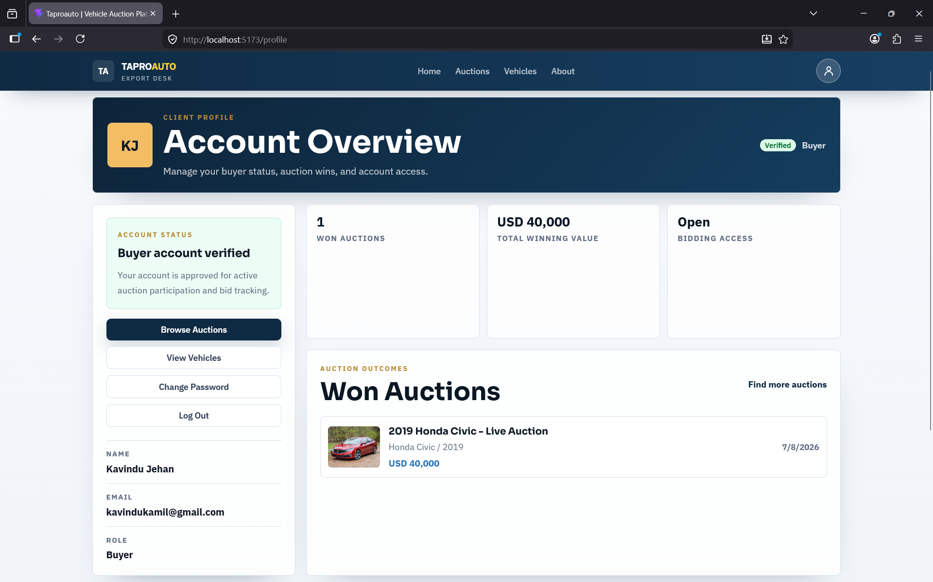

5. Administrator Features

5.1 Accessing the Admin Dashboard
Log in with an administrator account to be redirected automatically to the Admin Dashboard, available at any time from the Admin link in the navigation bar. The dashboard has three tabs: Vehicles, Auctions, and Users.
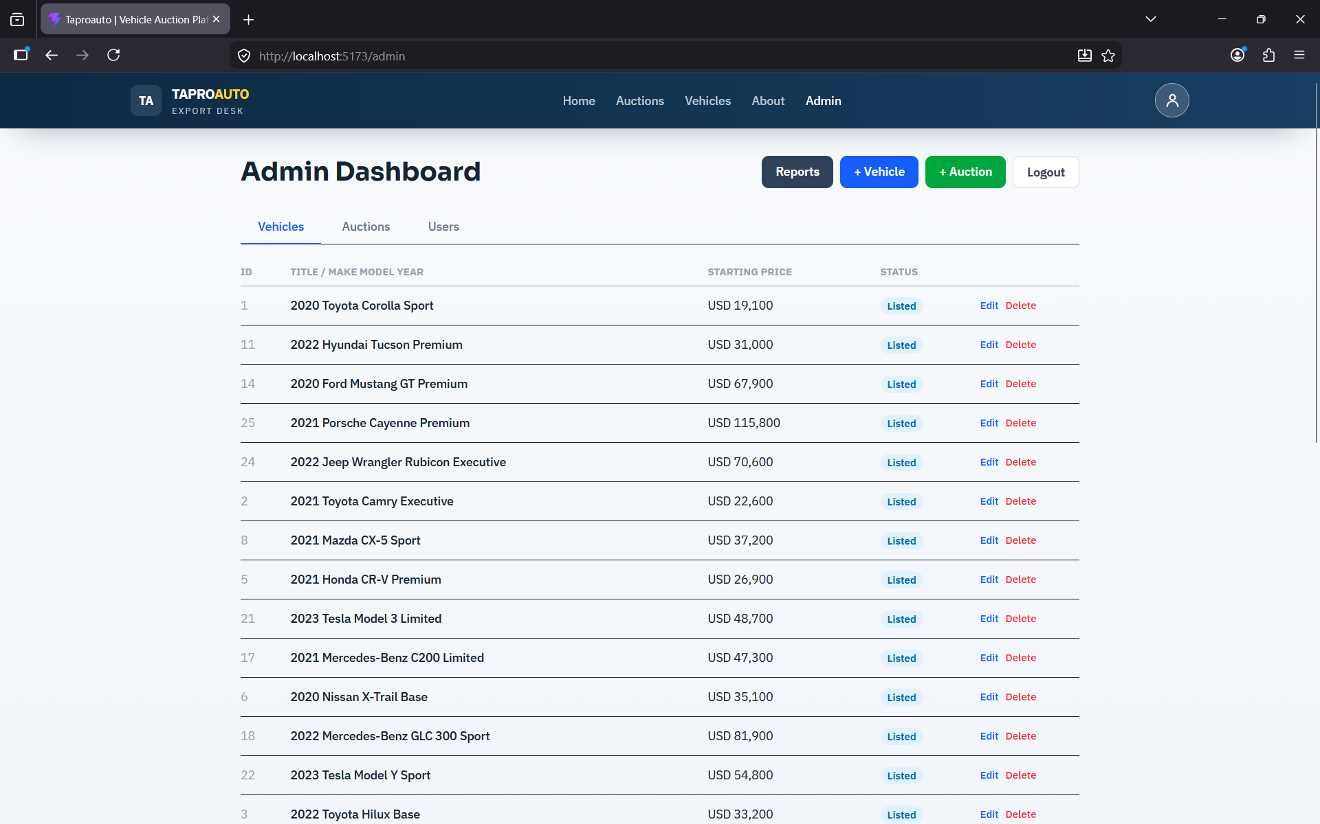

5.2 Managing Vehicles
The Vehicles tab lists every vehicle with options to edit or delete each entry, and an Add Vehicle button to create a new listing.
- Click Add Vehicle (or the edit icon on an existing vehicle).
- Fill in the title, description, make, model, year, starting price, chassis number, mileage, and grade.
- Upload one or more images — each is uploaded to the image hosting service immediately and a thumbnail preview appears.
- Click Save. The vehicle now appears in the public catalogue if its status is Listed.
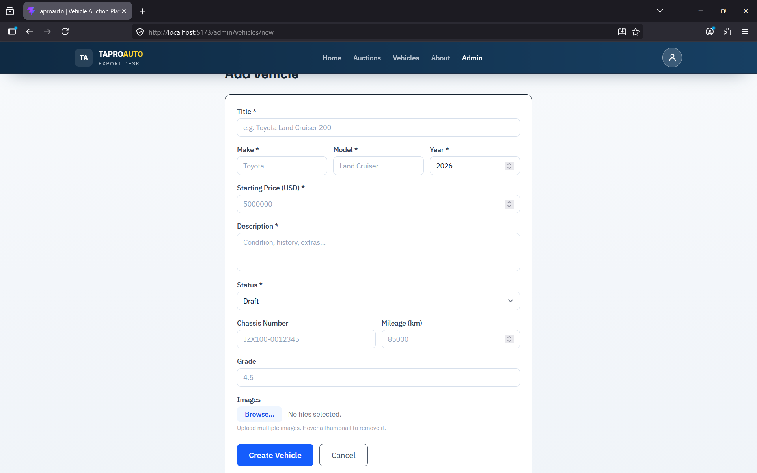

5.3 Managing Auctions
The Auctions tab lists all auctions. Use Add Auction to link a new auction to an existing vehicle, setting a start time, end time, minimum bid increment, and an optional reserve price. Administrators alone can see the actual reserve price amount on the auction detail page.
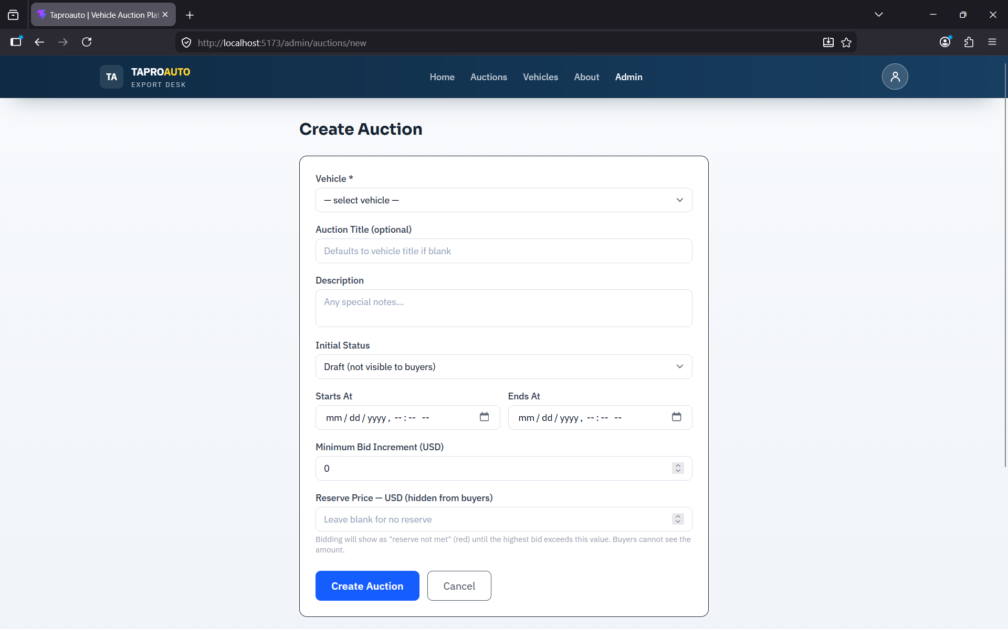
Two ways exist to end an auction:
- Automatically - the system checks every minute and moves an auction from Active to Ended once its end time has passed.
- Manually - click Close Auction on the auction detail page; this immediately ends the auction and assigns the current highest bid as the winner.
After closing, review the bid ladder and use Select Winner if you need to override the automatically assigned winner (for example, if the highest bid did not meet the reserve price).
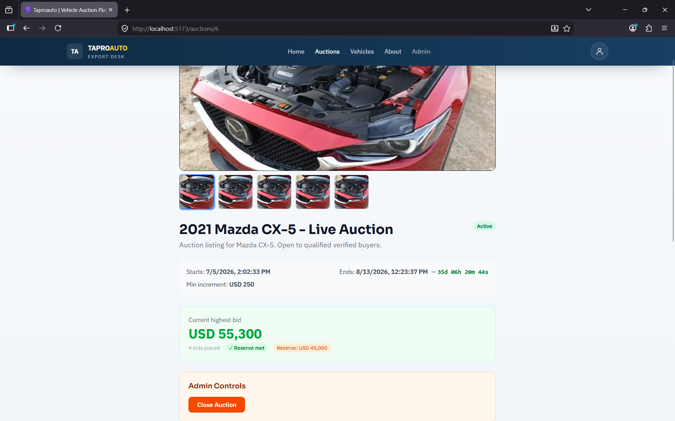

5.4 Managing Users
The Users tab lists every registered buyer with their current verification status: Pending, Verified, or Rejected.
- Locate the buyer awaiting verification (shown as Pending).
- Click Verify to approve the account, or Reject to deny it.
- The pending-count badge on the Admin navigation link updates immediately without a page reload.
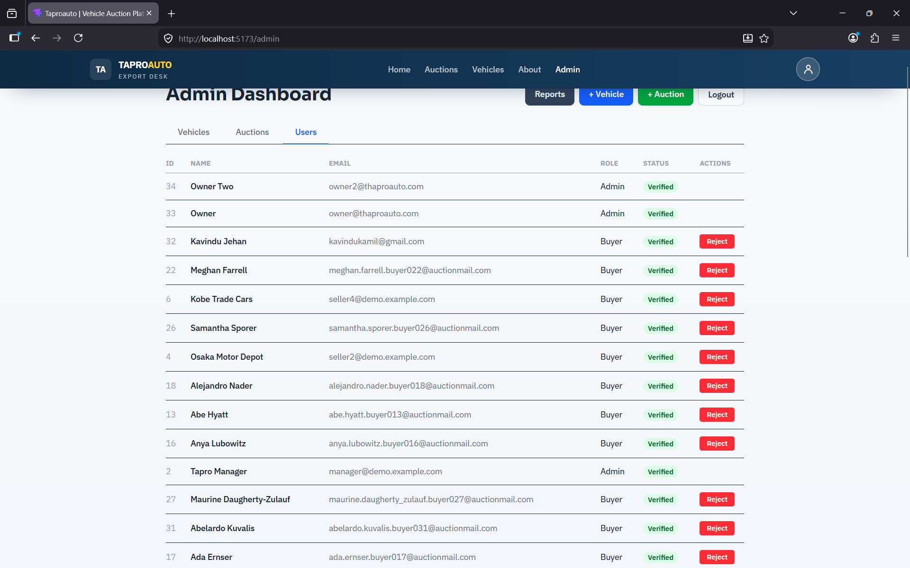

Note: A rejected buyer can be re-verified later if circumstances change; rejection is not permanent.

5.5 Reserve Price Visibility
Only administrators can see the exact reserve price figure on an auction. Buyers instead see a colour-coded indicator (no reserve, reserve not met, or reserve met) so pricing strategy stays confidential while bidders still know where they stand.

6. Account Security

6.1 Automatic Logout
For your security, you are automatically logged out after 30 minutes of inactivity. Any mouse movement, click, keystroke, or scroll resets this timer. If you are logged out, you will see a session-expired message on the Login page and can simply log in again.

6.2 Changing Your Password
Password changes are not yet self-service through the interface. Contact an administrator if you need your password reset.

7. Troubleshooting
Issue | What To Do
I cannot see the bid form on an active auction. | Confirm you are logged in and that your account has been verified by an administrator. Log out and log back in after verification.
My bid was rejected. | Your bid amount was below the current highest bid plus the minimum increment. Check the amounts shown on the auction page and try a higher bid.
I was logged out unexpectedly. | Sessions expire after 30 minutes of inactivity for security. Simply log in again.
Images are not uploading on the vehicle form. | Check your internet connection and that the file is a supported image format (JPG or PNG). Try a smaller file if the upload times out.
The pending-users badge did not update. | Refresh the page. The badge updates automatically after a Verify or Reject action but requires the browser tab to remain open.

8. Support
For further assistance beyond this manual, contact the system administrator or the development team using the contact details provided separately by TaproJapan Co. Ltd.
